PHASE 2 – INNOVATION

AI- BASED DIABETES PREDICTION SYSTEM WITH MACHINE LEARNING USING PYTHON

SHRINIDHI V-2021504041

VIBIKSHA J-2021504053

VINODHINI R-2021504054

CHARUMATHI-2021504508

In the previous phase, we designed an AI-based diabetes prediction system. Now, in the innovation phase, we will take the design and put it into action by transforming it into a functional and deployable system.

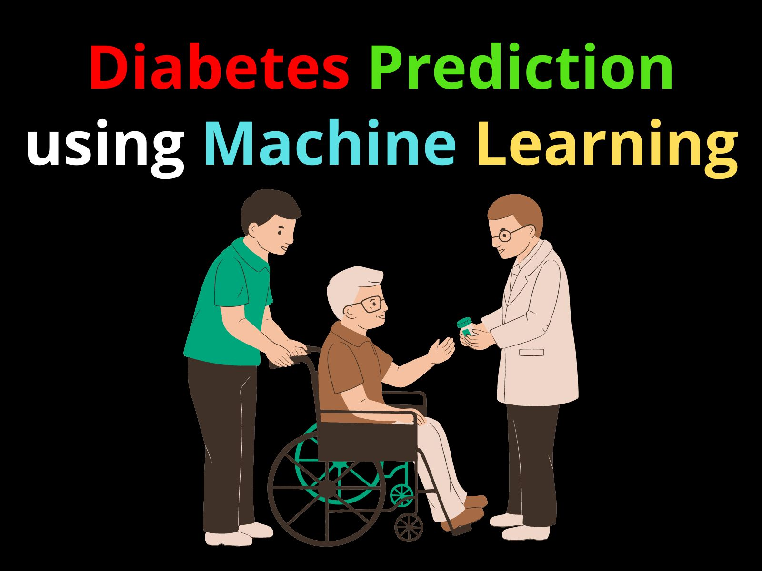

The key steps involved in this transformation are detailed below:

**STEP 1: DATA ACQUISITION AND PREPROCESSING**

**Data Collection:** Gather a comprehensive dataset that includes demographic information, clinical data, lifestyle factors, and medical history from reliable sources, such as healthcare institutions or research datasets.

**Data Preprocessing:** Clean and preprocess the collected data by handling missing values, standardizing numerical features, encoding categorical variables, and splitting the data into training and testing sets.

**STEP 2: MODEL DEVELOPMENT AND TRAINING**

**Algorithm Selection:** Choose the machine learning algorithm(s) suitable for diabetes prediction. Based on the project's goals and dataset characteristics, you can continue with the Random Forest Classifier as in the initial design or explore other advanced algorithms such as Support Vector Machines, Neural Networks, or Gradient Boosting.

**Hyperparameter Tuning:** Optimize the model's hyperparameters using techniques like Grid Search or Randomized Search to improve its performance.

Feature Engineering: Perform feature selection and engineering to identify the most relevant variables for prediction.

**STEP 3: SYSTEM ARCHITECTURE AND DEVELOPMENT**

**User Interface:** Create a user-friendly web-based interface for users, including healthcare professionals and individuals at risk of diabetes. The interface should allow users to input their data securely.

**Backend Development:** Develop the backend infrastructure responsible for data preprocessing, feature extraction, model prediction, and result presentation.

**Database Implementation:** Set up a secure database to store user profiles, historical data, and prediction results, ensuring compliance with data privacy regulations such as HIPAA.

**STEP 4: PRIVACY AND SECURITY**

**Privacy Compliance:** Ensure that the system complies with data privacy regulations by implementing encryption, access controls, and user authentication.

**Data Security:** Protect users' personal health information (PHI) by employing strong security measures, including secure data transmission and storage.

**STEP 5: DEPLOYMENT**

**Cloud Deployment:** Host the diabetes prediction system on a cloud-based platform (e.g., AWS, Azure, or Google Cloud) for scalability and accessibility.

**Integration:** Enable healthcare institutions to integrate the system into their existing healthcare systems for seamless patient management.

**Web and Mobile Access:** Provide access to the system through web portals and mobile applications for individuals to monitor their health and receive predictions.

**STEP 6: CONTINUOUS MONITORING AND IMPROVEMENT**

**Monitoring:** Implement continuous monitoring of users' health data to provide real-time updates and refine predictions over time.

Wearable Integration: Explore integration with wearable devices (e.g., fitness trackers) to collect real-time health data for more accurate predictions.

**Personalization:** Offer personalized recommendations for lifestyle changes based on individual risk factors, leveraging machine learning to adapt to users' evolving health conditions.

**STEP 7: EVALUATION AND FEEDBACK**

**User Feedback:** Gather feedback from healthcare professionals and users to assess the system's usability, accuracy, and effectiveness.

**Performance Evaluation:** Continuously evaluate the model's performance and consider retraining with new data to maintain accuracy.

**STEP 8: DOCUMENTATION AND TRAINING**

**User Documentation:** Prepare user guides and documentation to help healthcare professionals and users navigate the system effectively.

**Training:** Provide training to healthcare personnel on using the system for patient management and decision support.

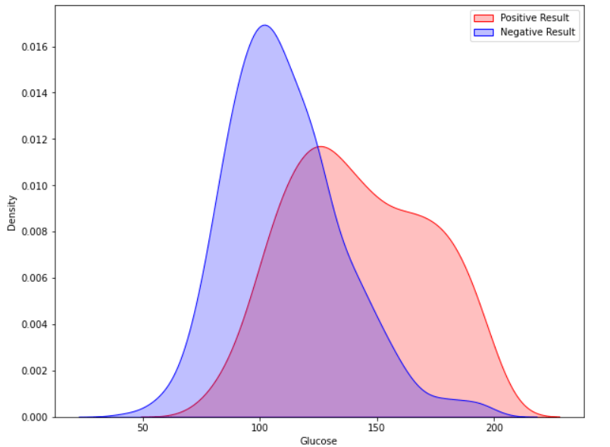

**STEP 9: SCALING AND EXPANSION**

**Scaling:** As user adoption grows, scale the system infrastructure to handle increased load and data volume.

**Internationalization:** Consider expanding the system's reach to different regions or languages, addressing global healthcare needs.

**STEP 10: RESEARCH AND INNOVATION**

**Research Collaboration:** Collaborate with healthcare research institutions to explore advanced prediction techniques, such as genetic markers or advanced imaging analysis.

**Innovation:** Stay up-to-date with the latest advancements in machine learning and healthcare to continually improve the system's predictive capabilities.

**ALGORITHM FOR THE CODE**

1.Load your diabetes dataset. Replace 'your_dataset.csv' with the actual path to your dataset file and adjust the target column name as needed.

2.Split the dataset into features (X) and the target variable (y).

3.Split the data into training and testing sets.

4.Standardize the features using StandardScaler.

5.We use a Support Vector Machine (SVM) classifier, a more advanced algorithm compared to the Random Forest classifier in the previous example.

6.We perform hyperparameter tuning using Grid Search (GridSearchCV) to find the best combination of hyperparameters (C, kernel, and gamma) for the SVM.

7.We fit the model with the best hyperparameters to the training data

8.Make predictions on the test data.

9.Evaluate the model using accuracy, a confusion matrix, and a classification report.

This code demonstrates how to use a more advanced algorithm (SVM) and optimize its hyperparameters for improved performance in diabetes prediction. Be sure to adjust the dataset and target column as needed.

**BLOCK DIAGRAM FOR THE PROPOSED MODEL**

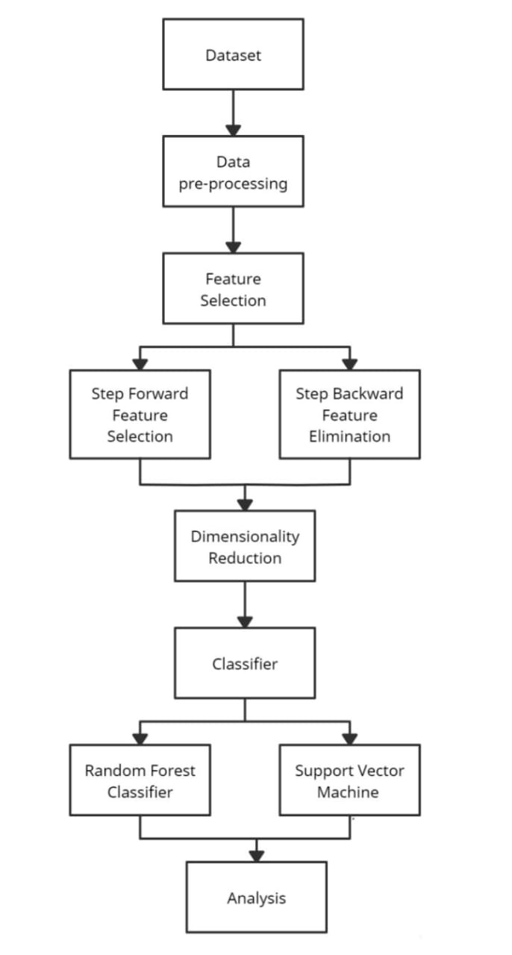

By following these steps, we can transform the initial design of the diabetes prediction system into an innovative, functional, and user-friendly solution that contributes to early diabetes risk assessment, management, and prevention while prioritizing data privacy and security.